# While loop in C++

Task 01:

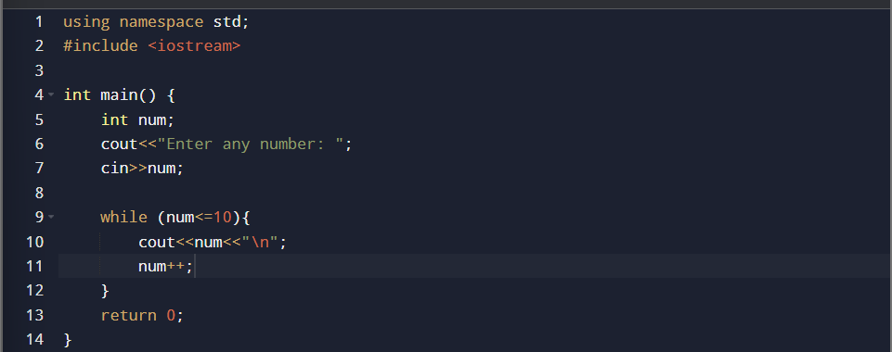

Task 02:

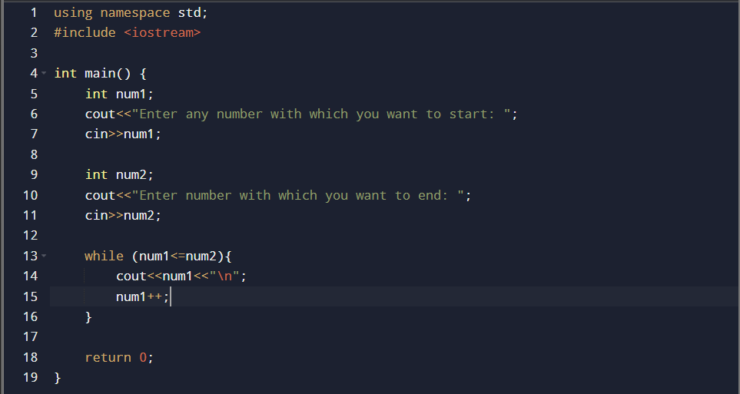

Task 03:

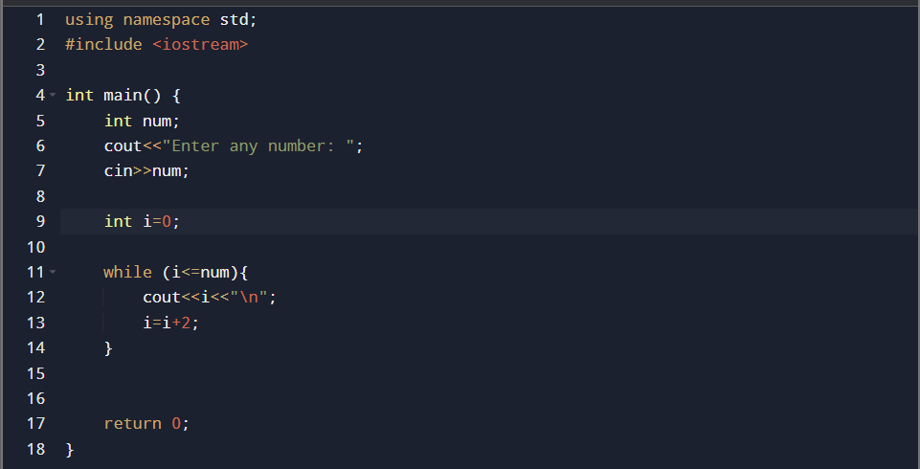

Task 04:

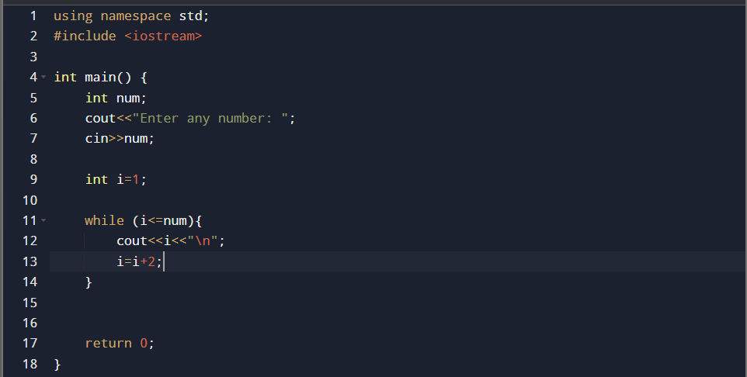

Task 05:

Summary for both even and odd:

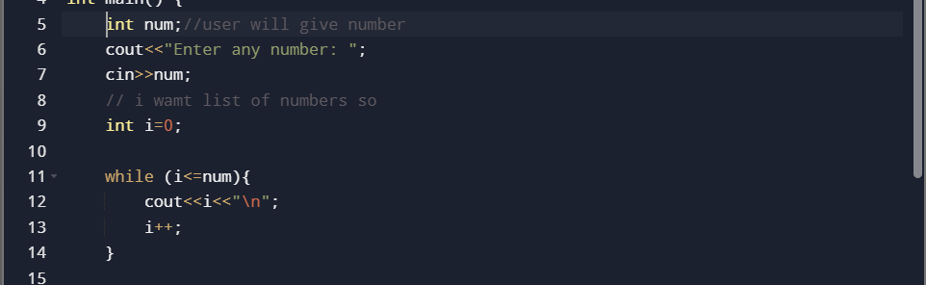

Task 06:

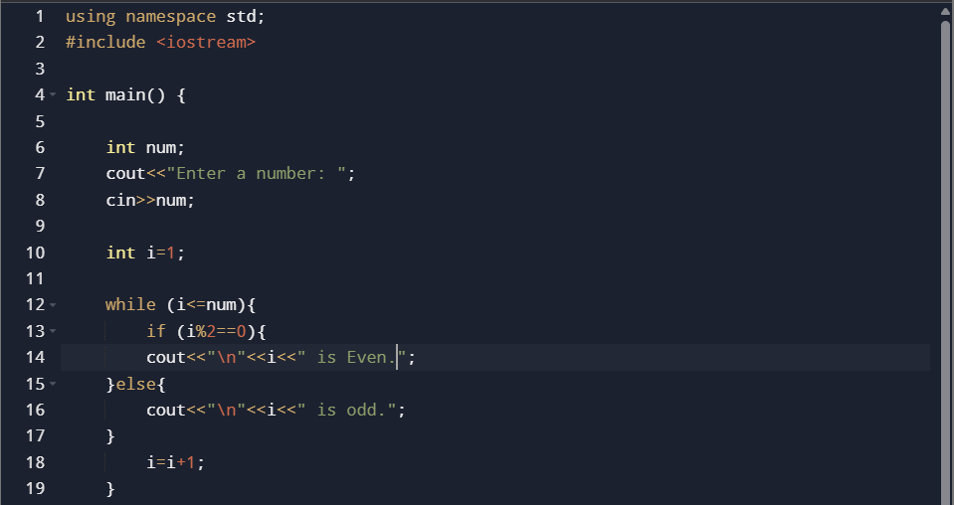

Task 07:

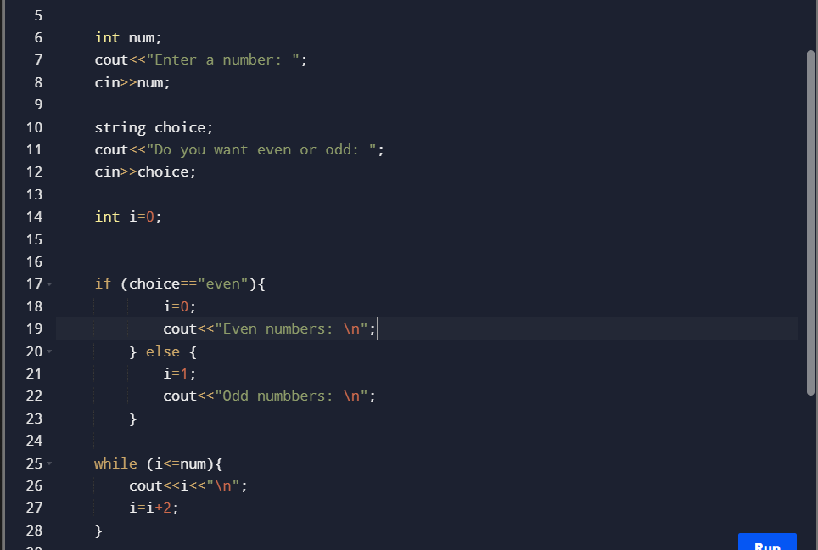

Task 08:

